Tribal Tourism Endorsement using Azure Bot and Microsoft Services.

Submitted By-

Divyansh Mittal

Tribal Tourism Endorsement using Azure Bot and Microsoft Services.

Problem Statement/Opportunity:

India had always been known as the land that portrayed cultural and traditional vibrancy through its conventional arts and crafts and tribes. It is a country that enjoys a unique Diaspora. Geographically, we are adorned by the great heights of Himalayas, to sprawling beaches, and dry terrains. But in the midst of all this, there are still some places which are unexplored and ignored. These places are not very much popular due to lack of knowledge about place or unclear roadmap. By, using the azure we can help Travel enthusiast, historophile, naturalist or highbrow to see and explore the underexplored places throughout the country. Problem which can we solved would be- Tribal tourism will create the jobs and employment for the tribal people. Tribal tourism will help the restoration of culture and tradition vibrancy of the region which is getting lost. Tourism attracts development and development attracts tourism.

Project Description:

Deploying a Azure chat Bot which will be very smart enough to provide the proper and clear idea for travelling more focused towards tribal tourism. It can help to provide the better suggestion to travel. In future prospect the azure Bot can be than further be trained and can be connected to the database of the travel list and booking sites. This can create a smooth experience for the professional and non professional traveler from the home to the destination and back. The need or the problem which can be solved are- 1) Economic independence through the tourism to local and tribal people. The tourist will visit those unexplored and tribal places. Stay there spends money on the local crafts and arts. This will create a better living lifestyle for the tribal and local people. 2) Preserving and promotion of the culture through the tourism. Since the old tribes and culture are getting vanished, the tourism to those places will help to maintain the root tribal culture and history of India. 3) Adventure and unexplored places for the tourist will open more interest of travel enthusiast to visit and enjoy. Tourism in India is an important for the country's economy and is growing rapidly. Millions of rupees of the revenue is generated from the tourism and tourist. Other important fact is India’s tribes, culture and history. If these dots connected with the Internet and azure services there will generation of revenue and development to tribal people along with maintaining prehistoric rituals, customs and culture even in today’s modern world.

Primary Azure Technology :

Azure Bot Service, QnA Maker, Visual Studio Code,

Methodology

The planning is done according to the deployment of the model.

The planning involves such as basic outline and working. This includes the learning resources, collection of methods, practices, processes, techniques, procedures, and rules. These usually contain a series of steps and activities for each phase of the project’s life cycle. They are defined approaches showing us exactly what steps to take next.

The required pictures and data can be obtained in this stage.

Deployment Using the Azure Services.

1. Using Azure Visual Studio Code.

The development of the website of done using the languages such as Html , J Query and JavaScript etc using the Visual Studio Code. This includes creation of various div and tags.

The code is then run and compiled using the visual Studio Code.

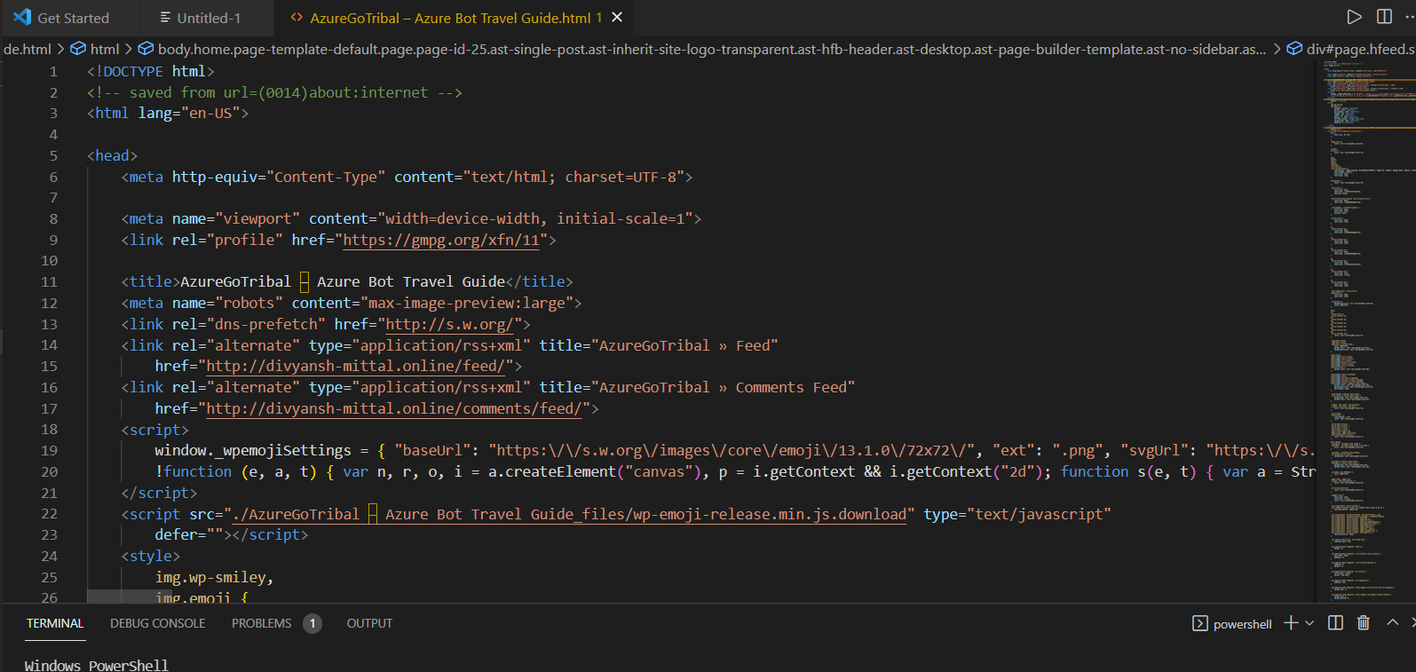

1. Using Q&A Maker to create a Questions Database.

Question and Answer Maker create a question structure which is setup to make structured question and answer.

We can choose from various styles like the friendly, professional ,witty caring etc.

This service can fetch questions from various FAQ and also we can provide the editorial Answer to it.

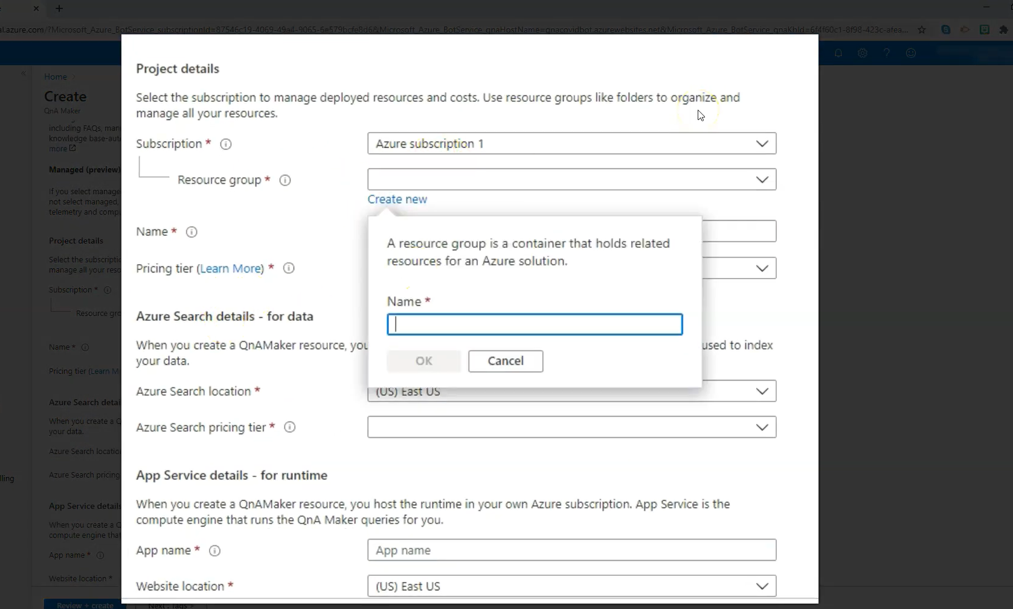

Select the Required information such as the App name, website location etc.

The Knowledge base is trained so that it can give more accurate answer. The quality of answer depends upon the confidence level of the bot.

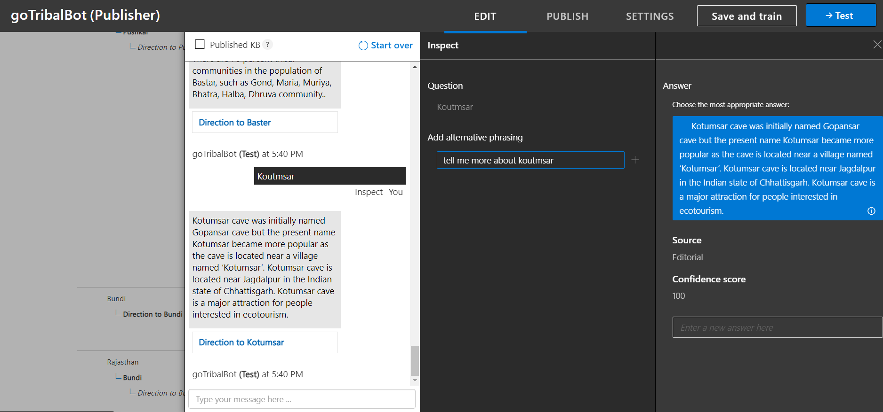

The test and training is very much important so that I can give the accurate answer to the query.

The more the accuracy of answer will give more the experience of Human based conversation.

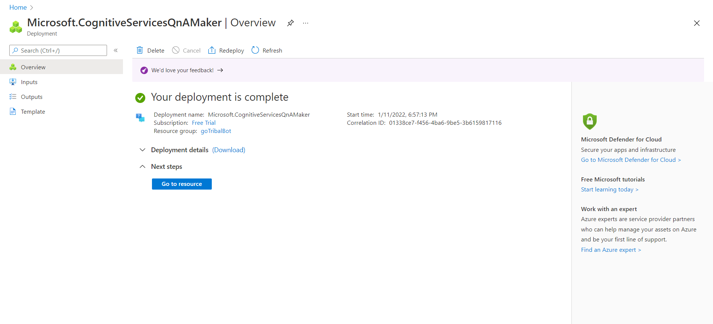

1. Using Azure Bot to create.

Azure Bot Develop enterprise-grade conversational AI experiences while maintaining control of data. These multilingual and multimodal bots can be used for any scenario from sales to customer support and employee productivity.

These bot can then be integrated with various channels such as website, facebook web and teams etc.

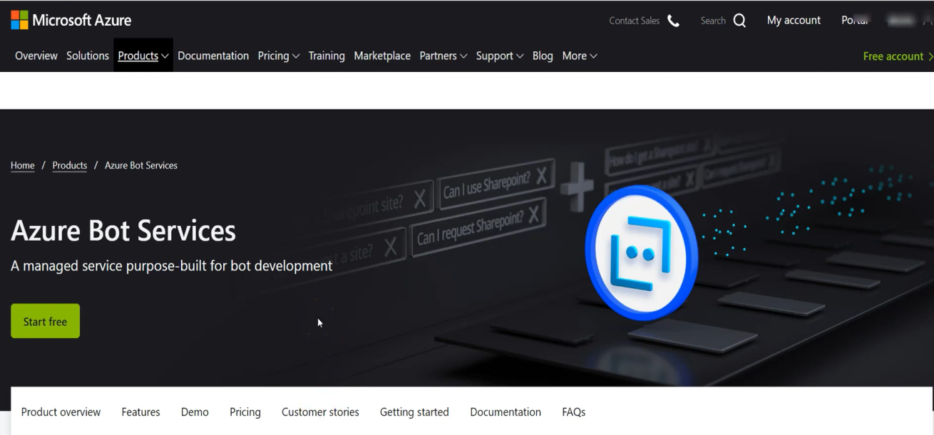

After all the steps train the Bot as much as possible with different combinations.

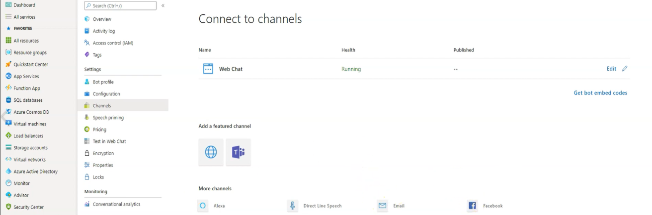

The Connection is done with the required channel. Here we have done with the website.

1. Final Deployment on Project-

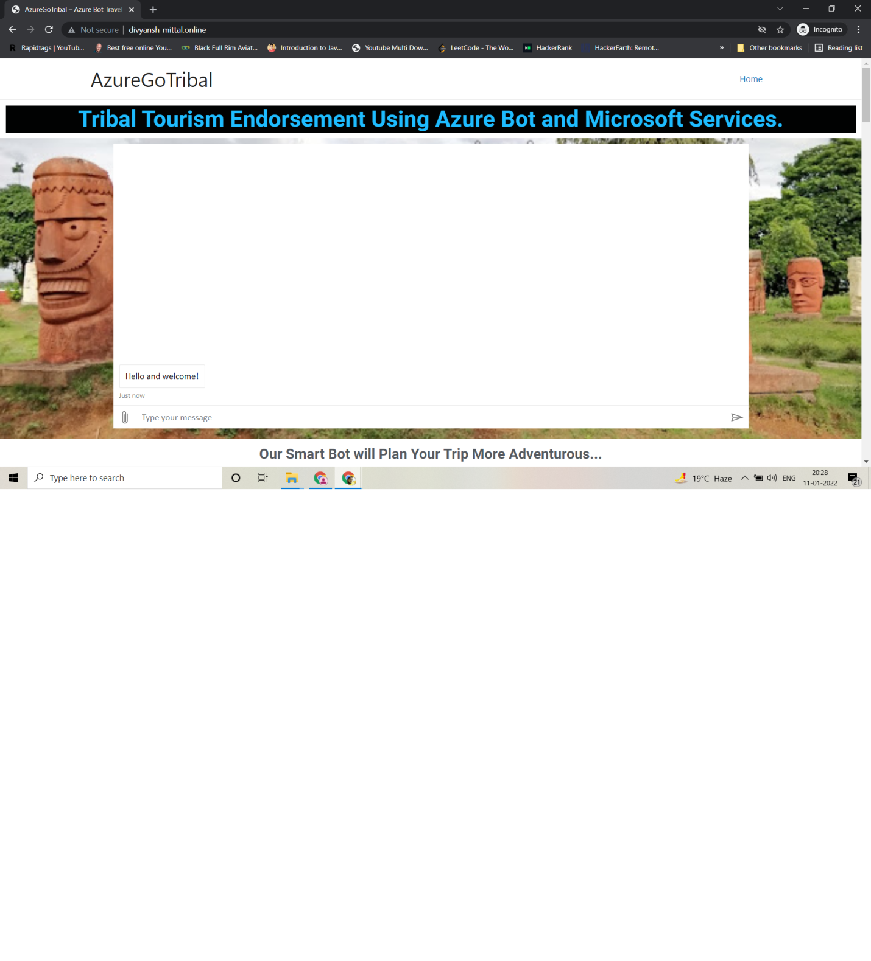

Future Scope-

* The Bot will understand as well as respond to complex requests more efficiently.
* The services than can be developed for android and iphones so that the application can be accessed more easily.
* The bot can be useful for the tourism development.
* The Planning of any trip can be done with accuracy and without delay with the help of Ai bot

Thank You